DWIT COLLEGE
DEERWALK INSTITUTE OF TECHNOLOGY



TETRIS

A PROJECT – I PROPOSAL REPORT
Submitted to
Department of Computer Science
DWIT College

Submitted by
Drishya Karki
19/12/2025

TABLE OF CONTENTS
INTRODUCTION 3
BACKGROUND STUDY & LITERATURE REVIEW 4
PROBLEM STATEMENT 5
OBJECTIVES 6
SCOPE OF THE PROJECT 7
REQUIREMENT IDENTIFICATION 8
PROJECT SCHEDULE (GANTT CHART) 11
EXPECTED OUTCOMES 12
LIMITATIONS 13
FUTURE ENHANCEMENTS 13
CONCLUSION 14
REFERENCES 14

LIST OF FIGURE
Figure 1 :Scope 8
Figure 2: Iterative Development 11
Figure 3: Gantt Chart 12
Figure 4: Expected Outcomes 13

INTRODUCTION
Game development is an important practical domain within computer science that integrates programming, algorithms, mathematics, graphics, and real-time system concepts. Developing games allows students to apply theoretical knowledge in a dynamic and interactive environment. Among classic video games, Tetris remains one of the most influential puzzle games ever created.

Originally developed in 1984 by Alexey Pajitnov, Tetris is a tile-matching puzzle game where geometric shapes known as [3]tetrominoes fall from the top of the screen into a rectangular grid. The player must rotate and position these shapes to form complete horizontal lines. When a line is completed, it is cleared, and the player earns points.

Despite its simple appearance, Tetris involves complex internal logic such as collision detection, rotation handling near boundaries, real-time input processing, and state management. As the game progresses, the speed increases, requiring quicker decision-making and precision.

This project proposes the development of a Hard Mode Tetris game using C++ [1] and the [2]Raylib graphics library. Hard Mode introduces increased falling speed, stricter movement timing, and reduced player reaction time, making the game significantly more challenging than standard versions.

The primary aim of this project is to design a well-structured, modular, and optimized Tetris game that demonstrates object-oriented programming principles, real-time system behavior, and efficient algorithmic design. This project serves as an academic exercise for third-semester students to gain hands-on experience in software engineering and game development.

BACKGROUND STUDY & LITERATURE REVIEW
Tetris has been widely studied and implemented in computer science education due to its simple rules combined with complex underlying logic. Many researchers have used Tetris to demonstrate algorithmic problem-solving, artificial intelligence techniques, and human-computer interaction models. Several beginner-level Tetris implementations are available online; however, most of them focus only on basic gameplay mechanics such as block movement and line clearing. These implementations often lack structured design, scalability, and performance optimization, limiting their educational value. [2]Raylib is a lightweight C/C++ graphics library designed specifically for learning game programming. According to its official documentation, [2]Raylib provides simple APIs for graphics rendering, input handling, window management, and timing control. This allows developers to focus on game logic rather than low-level graphics programming. Previous academic projects using [2]Raylib demonstrate that it is well-suited for real-time applications and educational use. By combining C++ with [2]Raylib, this project builds upon existing studies and extends them by introducing Hard Mode gameplay mechanics, advanced collision handling, and difficulty scaling.

PROBLEM STATEMENT
Many academic programming projects remain limited to console-based or static applications. Such projects do not effectively demonstrate real-time processing, continuous user input handling, or dynamic system behavior. Basic Tetris implementations commonly found in tutorials fail to address: Proper object-oriented architecture, Efficient collision detection algorithms, Rotation handling near walls and stacked blocks, Difficulty progression and speed scaling. As a result, students do not gain sufficient exposure to realistic software development challenges.
The problem addressed by this project is the lack of a structured, advanced, and academically suitable Tetris implementation that demonstrates both gameplay complexity and sound software engineering practices.

OBJECTIVES
General Objective
To design and develop a fully functional Hard Mode Tetris game using C++[1] that demonstrates real-time processing and object-oriented programming principles.
Specific Objectives
- To implement a real-time game loop
- To apply abstraction, encapsulation, and modular design
- To develop efficient collision detection mechanisms
- To implement advanced rotation logic near grid boundaries
- To introduce difficulty scaling through speed progression
- To optimize performance and memory usage
- To gain hands-on experience with the [2]Raylib graphics library

SCOPE OF THE PROJECT
The scope of this project includes the design and development of a single-player Hard Mode Tetris game for desktop platforms. The project focuses on gameplay logic, grid-based rendering, real-time input handling, and performance optimization.
The scope is limited to offline gameplay and does not include multiplayer functionality, mobile deployment, or online features.
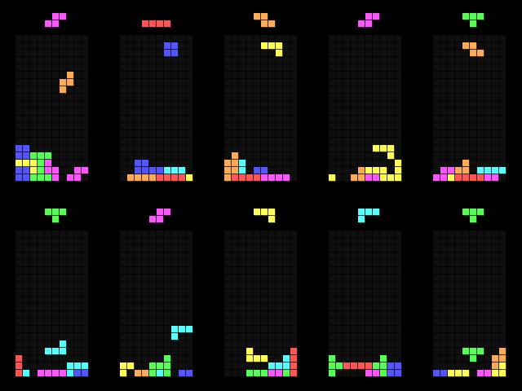

Figure 1 :Scope

REQUIREMENT IDENTIFICATION

6.1 Requirement Identification
Requirement identification involves determining the system capabilities needed to achieve the project objectives. The game requires continuous input handling, accurate collision detection, grid-based rendering, score tracking, and real-time difficulty progression.

6.2 Functional Requirements
- The system shall display a standard 10×20 Tetris grid
- The system shall generate random [3]tetrominoes
- The system shall allow user-controlled movement and rotation
- The system shall detect collisions accurately
- The system shall clear completed horizontal lines
- The system shall update the score dynamically
- The system shall increase falling speed over time
- The system shall detect game-over conditions

6.3 Non-Functional Requirements
- The system must provide smooth and lag-free performance
- The system must respond immediately to user input
- The code must be modular and maintainable
- The system must handle edge cases reliably

6.4 Feasibility Study
6.4.1 Technical Feasibility
The project is technically feasible using C++ and [2]Raylib. Modern compilers and open-source libraries provide all required functionality for real-time graphics, input handling, and timing control.

6.4.2 Operational Feasibility
The game is easy to operate using keyboard controls. No specialized training is required for users to play the game.

6.4.3 Economic Feasibility
All tools used in this project, including the compiler and [2]Raylib, are open-source and free of cost. Therefore, the project is economically feasible.

6.5 High-Level System Design
The system follows a real-time game loop architecture consisting of:
- Input Handling
- Game Logic Update
- Rendering
Each module operates independently, ensuring modularity and ease of maintenance.

6.6 Development Model
An iterative development model is adopted. Features are implemented incrementally, tested, and refined. This approach allows continuous improvement and early detection of issues.
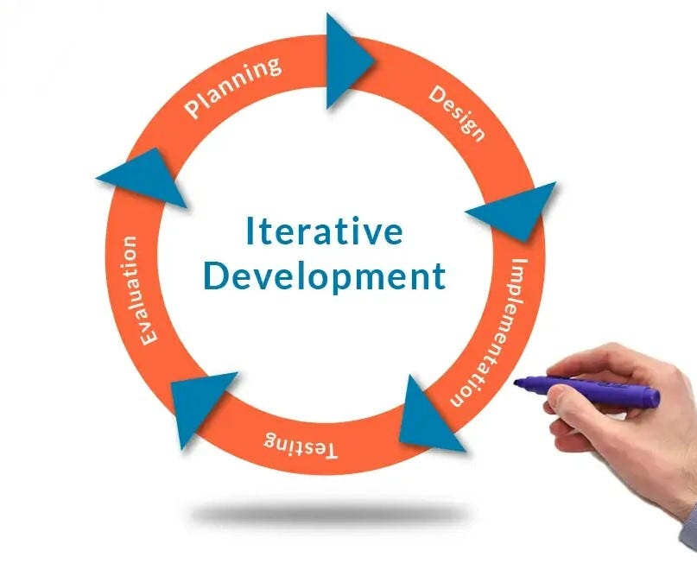

Figure 2: Iterative Development

7. PROJECT SCHEDULE (GANTT CHART)
The project schedule includes phases such as proposal defense, requirement analysis, system design, implementation, testing, optimization, and final evaluation. A Gantt chart is used to visually represent the project timeline.

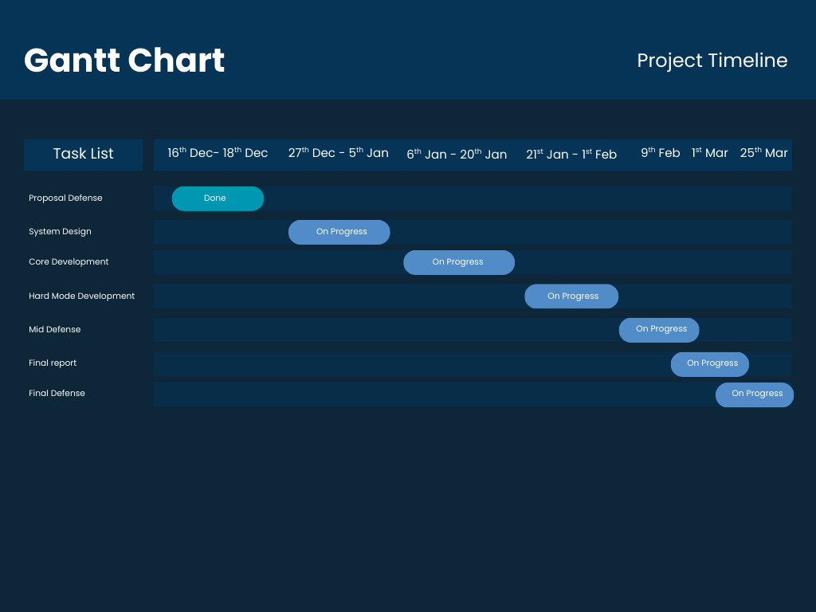
Figure 3: Gantt Chart

8. EXPECTED OUTCOMES
The expected outcomes of this project include:
- A fully playable Tetris game
- Efficient and optimized game logic
- Clean object-oriented code architecture
- Improved understanding of real-time systems
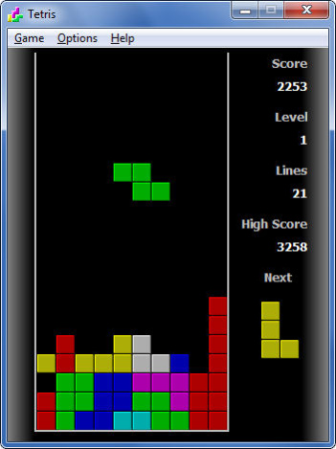

Figure 4: Expected Outcomes

9. LIMITATIONS
- The game supports only single-player mode
- The project is limited to desktop platforms
- Advanced graphical effects are not included

10. FUTURE ENHANCEMENTS
- Multiplayer functionality
- Mobile platform support
- AI-based opponent or gameplay analysis
- Advanced animations and sound effects

11. CONCLUSION
This project provides a comprehensive learning experience in game development and software engineering. The Hard Mode Tetris game effectively demonstrates real-time programming, object-oriented design, and performance optimization, making it a strong and academically valuable Project-I submission.

12. REFERENCES
- [1] Stroustrup, B. The C++ Programming Language
- [2] Raylib Documentation – https://www.raylib.com
- [3]Tetrimonoes - https://tetris.fandom.com/wiki/Tetromino
- Nystrom, R. Game Programming Patterns
- W3s schools : https://www.w3schools.com/
- Youtube : https://www.youtube.com/watch?v=wVYKG_ch4yM&t=365s

